● What are events in Google analytics?

ans:**Events** are user interactions with content that can be tracked independently from a web page or screen load. Examples:

* Downloads
* Link clicks
* Form submissions
* Video plays

In **Google Analytics 4 (GA4)**, events are the foundation — everything is tracked as an event

2.Connect your created website and blog to search console, analytics, and google tag manager and add your faculty as a user with required permission in it.

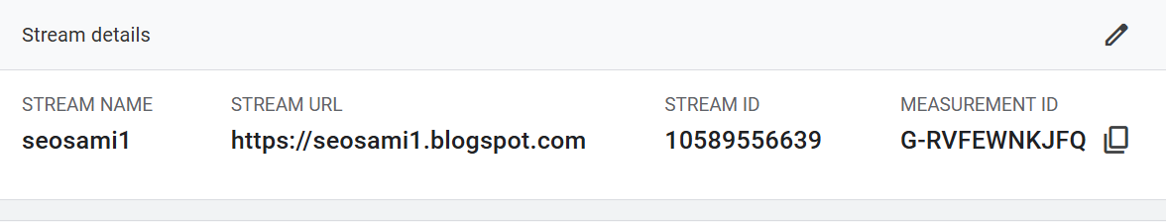

3. Submit the sitemap and robot.txt file in the search console for your website.

Ans: sitemap: <https://www.xml-sitemaps.com/download/www.esellerhub.com-49a9239ab/sitemap.xml?view=1>

robot.txt:robots.txt generated by www.seoptimer.com

User-agent: Googlebot

Disallow:

User-agent: googlebot-image

Disallow:

User-agent: googlebot-mobile

Disallow:

User-agent: MSNBot

Disallow:

User-agent: Slurp

Disallow:

User-agent: Gigabot

Disallow:

User-agent: Robozilla

Disallow:

User-agent: Nutch

Disallow:

User-agent: naverbot

Disallow:

User-agent: yeti

Disallow:

User-agent: yahoo-mmcrawler

Disallow:

User-agent: psbot

Disallow:

User-agent: yahoo-blogs/v3.9

Disallow:

User-agent: *

Disallow:

Disallow: /cgi-bin/

Sitemap: https://www.xml-sitemaps.com/download/www.esellerhub.com-49a9239ab/sitemap.xml?view=1

4.Submit the user flow and traffic source reports for your website

Ans:

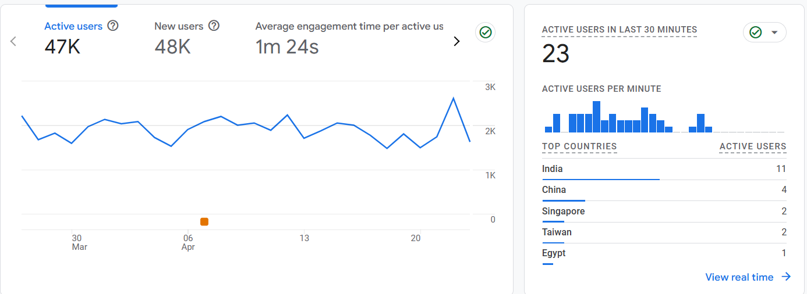

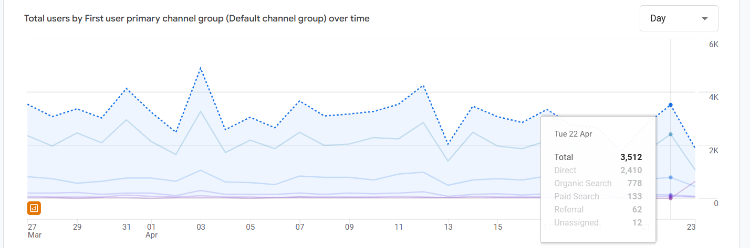

Connect your blog to Google Analytics and study the different types of traffic on your site.

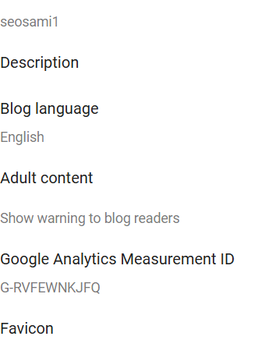

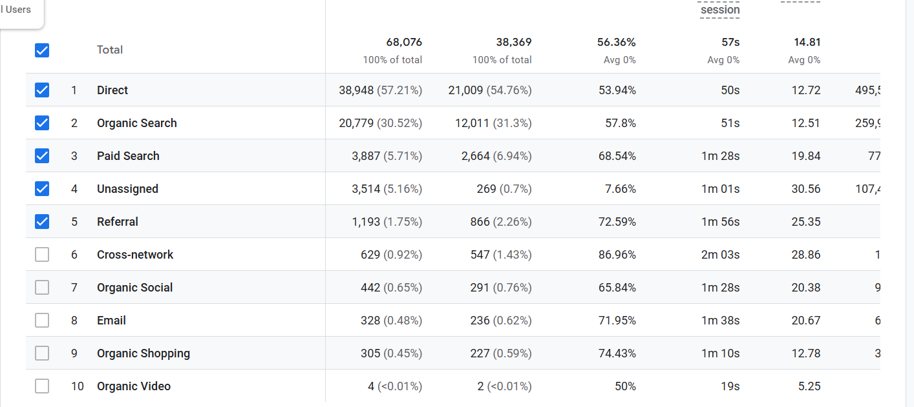

5.Create a goal for your business and study reports whether it has been completed or not.

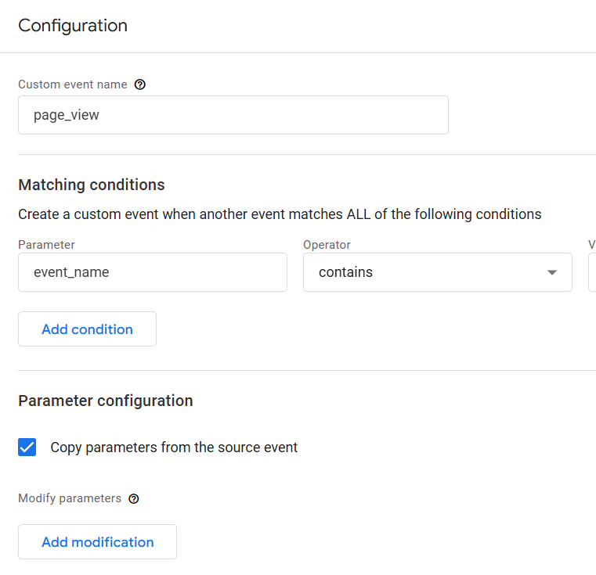

● Track the following interactions in Google tag manager for www.esellerhub.com ● Link clicks ● Page load ● Time (How long a visitor stayed on a particular page ) ● Button click

Ans: